Create Database, Tables, and Grant User Access
1. Launch an RDS MySQL Instance
- Go to AWS Console → RDS → Create database
- Select Standard Create
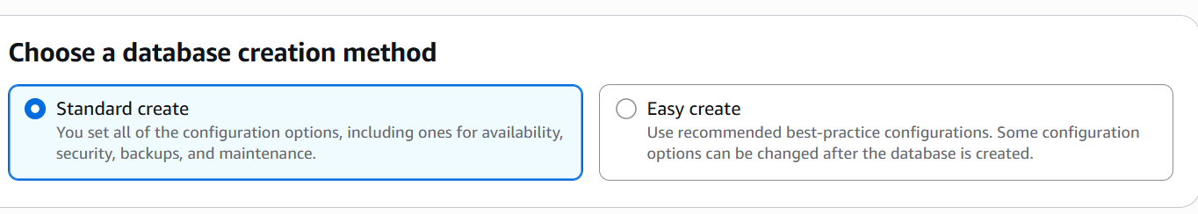
- Engine: Mssql (choose version like 8.0)
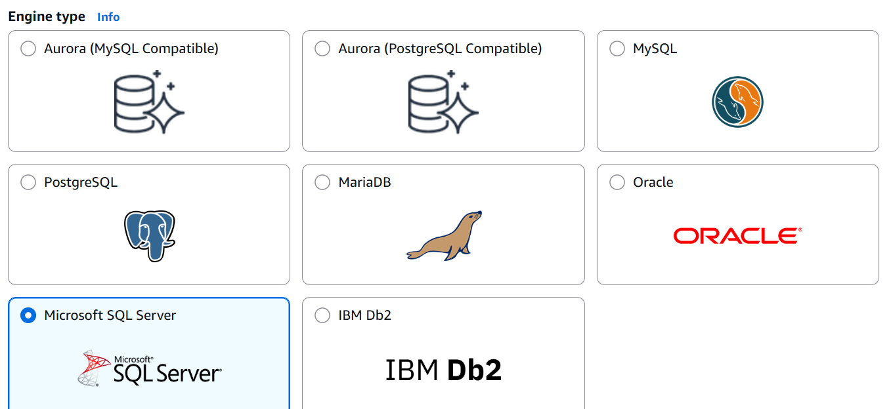
- DB Instance Identifier: demo-db
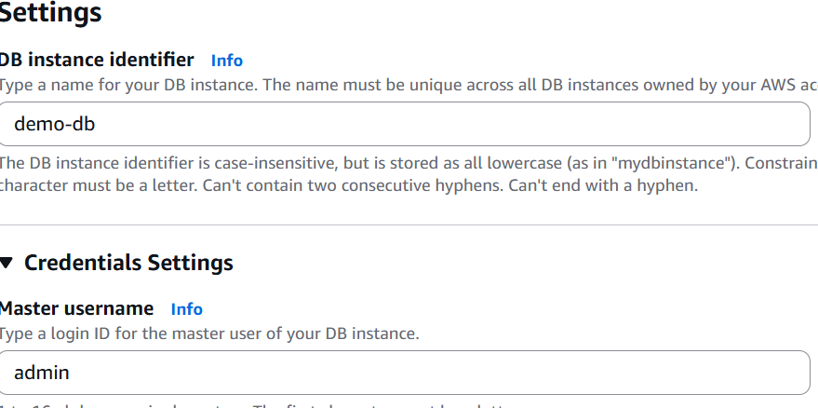
- Credentials:
  - Master username: admin
  - Password: MyDatabasePassword
- DB instance size: Use db.t3.micro for practice (Free tier eligible)
- Storage: 20 GB
- Connectivity:
  - VPC: Default
  - Public access: Yes (for connecting via MySQL Workbench or SSMS)
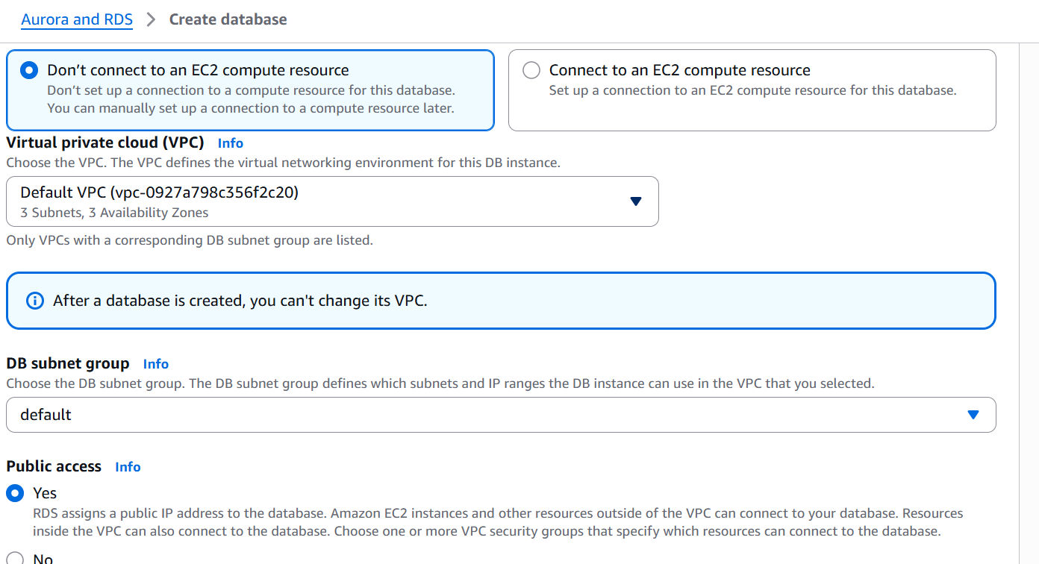
  - Add your IP to inbound rules in security group
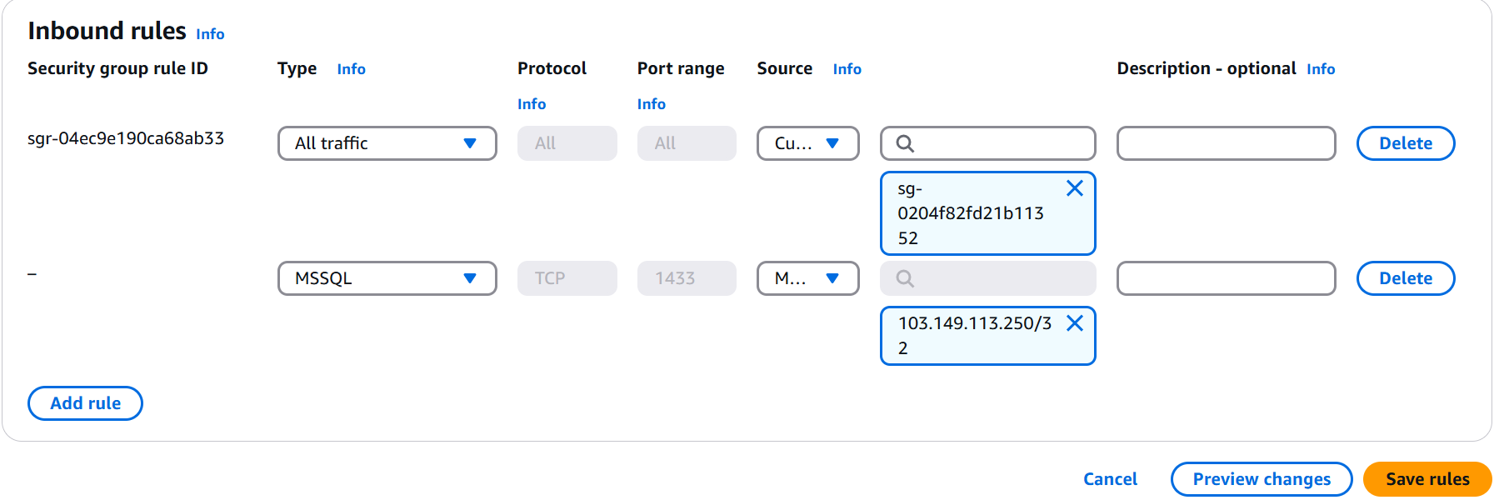
- Click Create Database

2. Connect to the DB

Steps to Connect AWS RDS SQL Server to SSMS
Step 2: Find Your RDS Endpoint
- Open AWS Console → Go to RDS
- Click on your SQL Server database from the list
- In the Connectivity & Security section

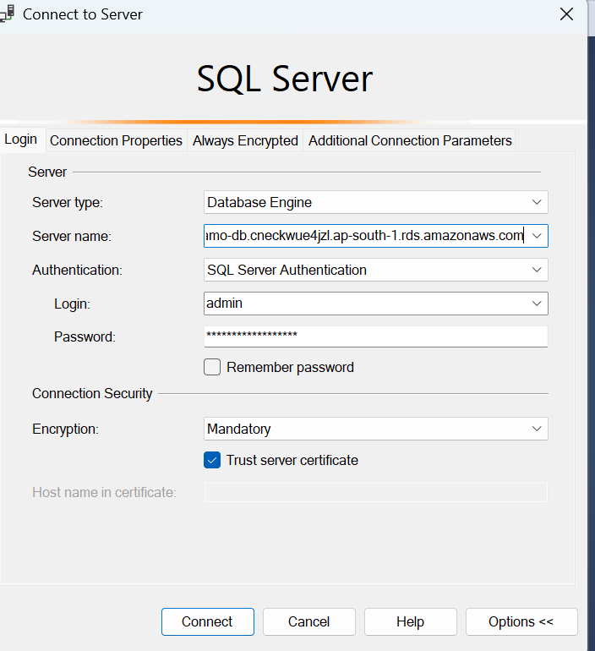
Create Database :
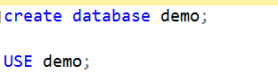
Create Tables:

CREATE TABLE location (
location_id INT PRIMARY KEY,
city VARCHAR(100),
state VARCHAR(100)
);
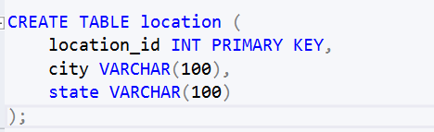

CREATE TABLE department (
dept_id INT PRIMARY KEY,
dept_name VARCHAR(100),
location_id INT,
FOREIGN KEY (location_id) REFERENCES location(location_id)
);
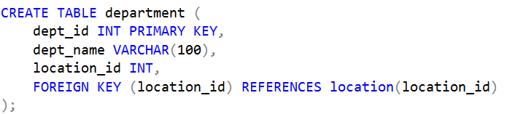
CREATE TABLE emp (
emp_id INT PRIMARY KEY,
emp_name VARCHAR(100),
dept_id INT,
salary DECIMAL(10,2),
FOREIGN KEY (dept_id) REFERENCES department(dept_id)
);
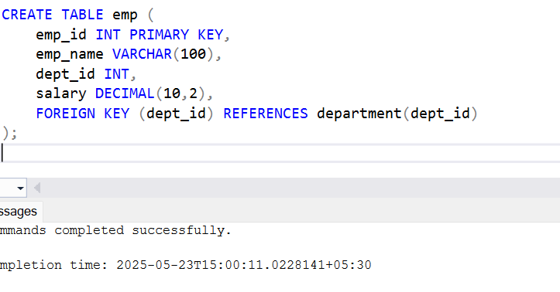
- Create Users and Grant Access
CREATE LOGIN user1 WITH PASSWORD = 'User1Pass@123';
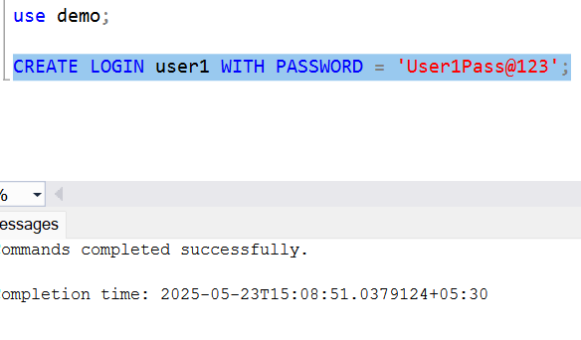
Step 2: Create a User in your database (after switching to your database)
CREATE USER user1 FOR LOGIN user1;
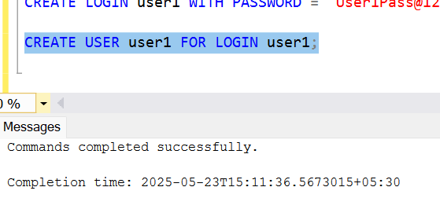
Step 3: Grant Permissions
GRANT SELECT ON location TO user1;
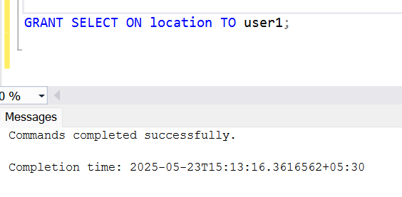
Do the same for user2:
🔹 Create Login & User
CREATE LOGIN user2 WITH PASSWORD = 'User2Pass@123';
USE demo;
CREATE USER user2 FOR LOGIN user2;
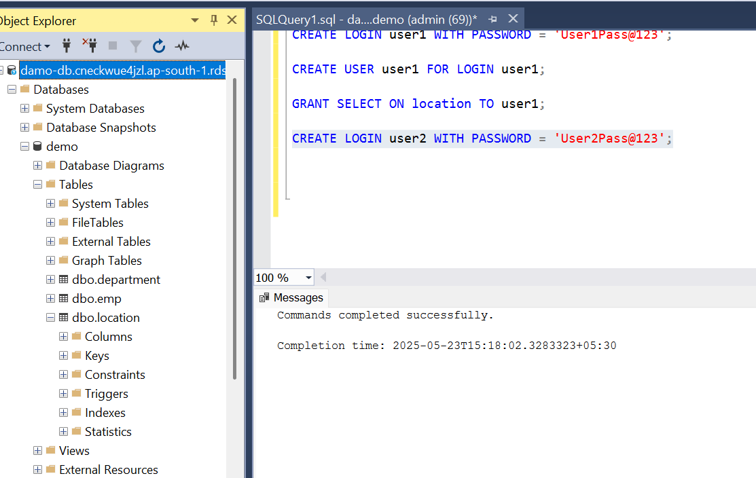
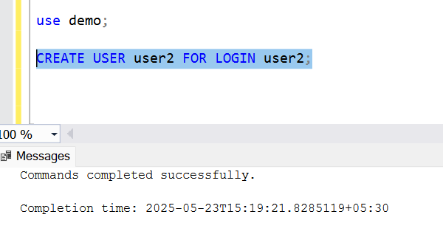
Grant full access on emp and department:
GRANT SELECT, INSERT, UPDATE, DELETE ON emp TO user2;
GRANT SELECT, INSERT, UPDATE, DELETE ON department TO user2;
